

**THE UNIVERSITY OF TEXAS AT ARLINGTON, TEXAS  
DEPARTMENT OF ELECTRICAL ENGINEERING**

**EE 5327 - 001**

**SYSTEM IDENTIFICATION & ESTIMATION**

**Project #1**

**EXAM**

**by**

**SOUTRIK MAITI**

**1001569883**

**Presented to**

**Prof. Michael Niestroy**

**Oct 25th, 2017**

1. Implementing the 2nd order differential equation

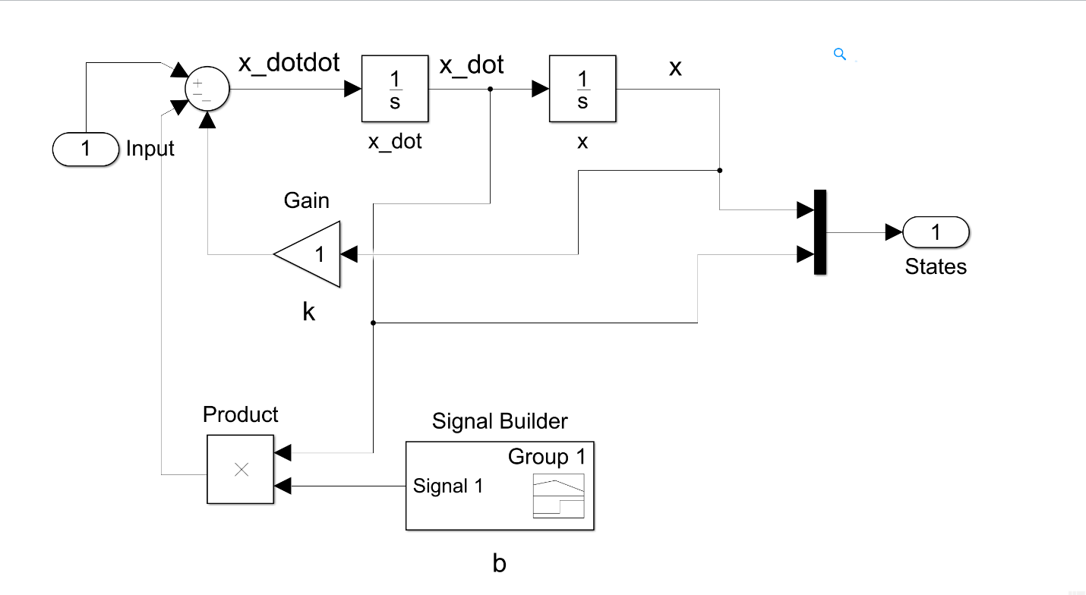

*A signal generator is used to give the system, the values of b at different time.*

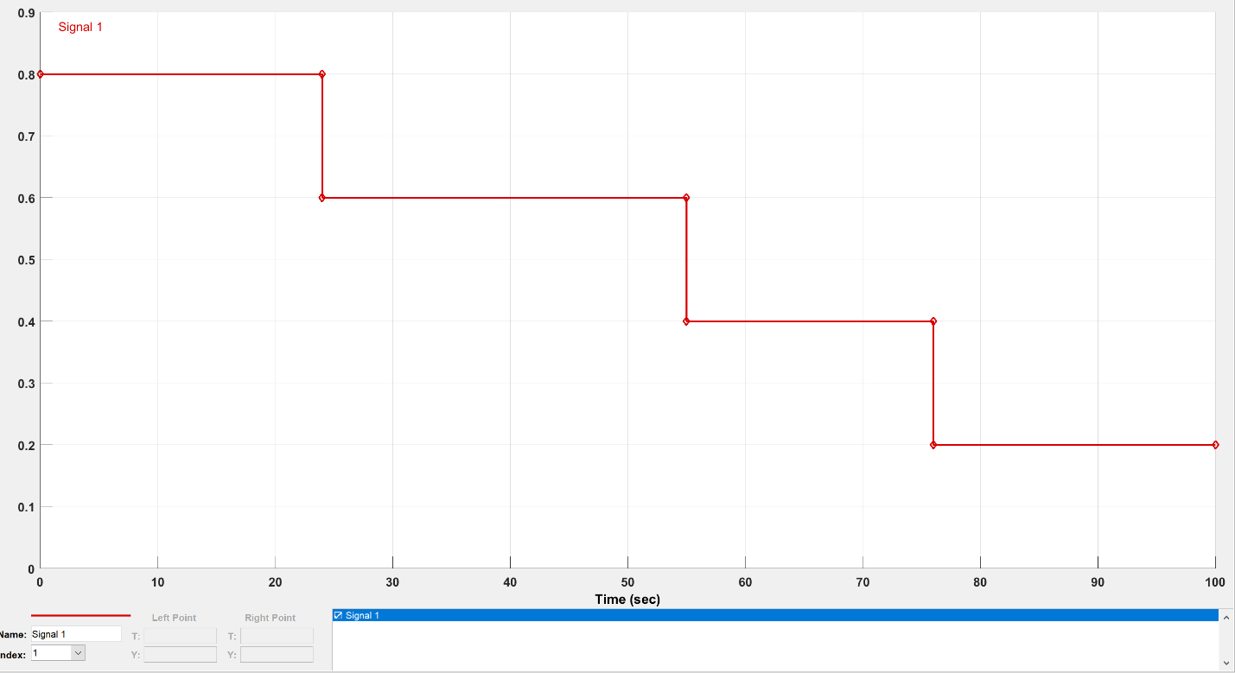

*The block parameters of the square wave used as an input to the system.*

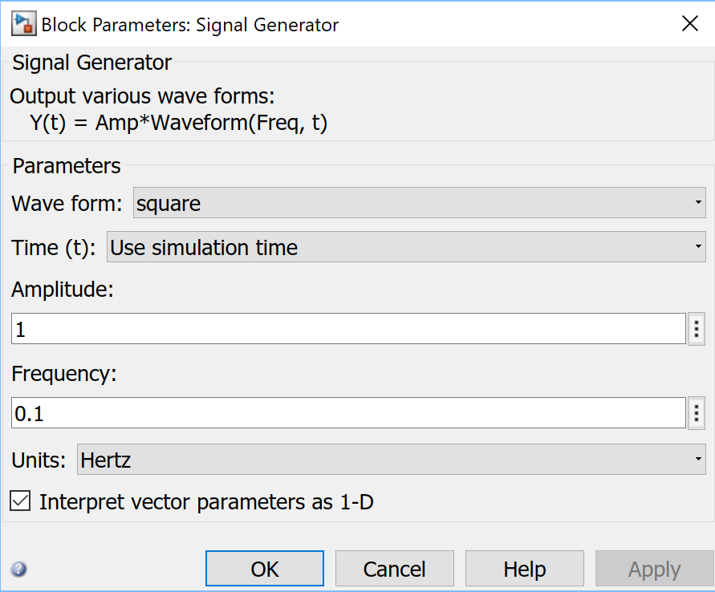

*Output of the plant – The actual states of the system*

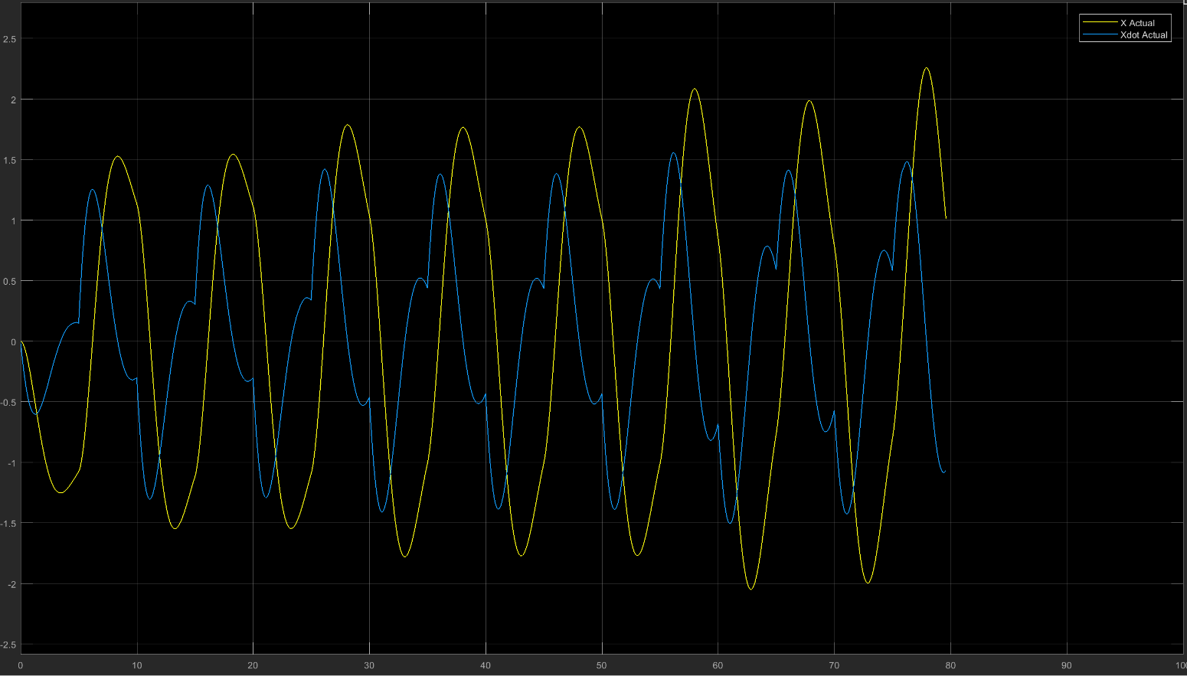

1. Noisy output after adding random noise to the output.

The noise added have the following properties :

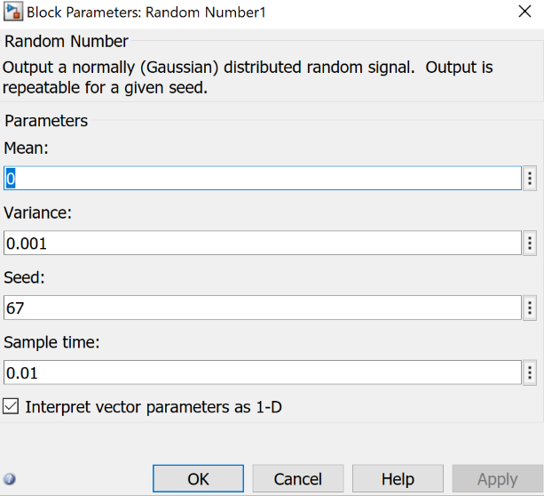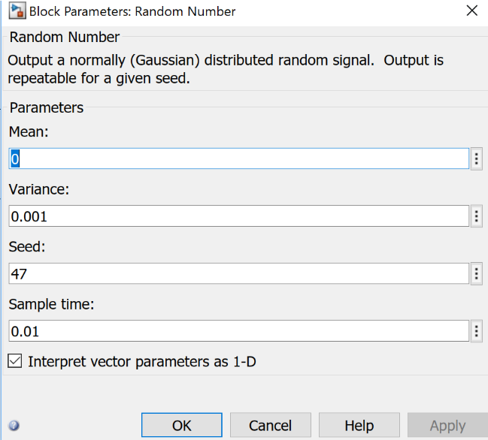

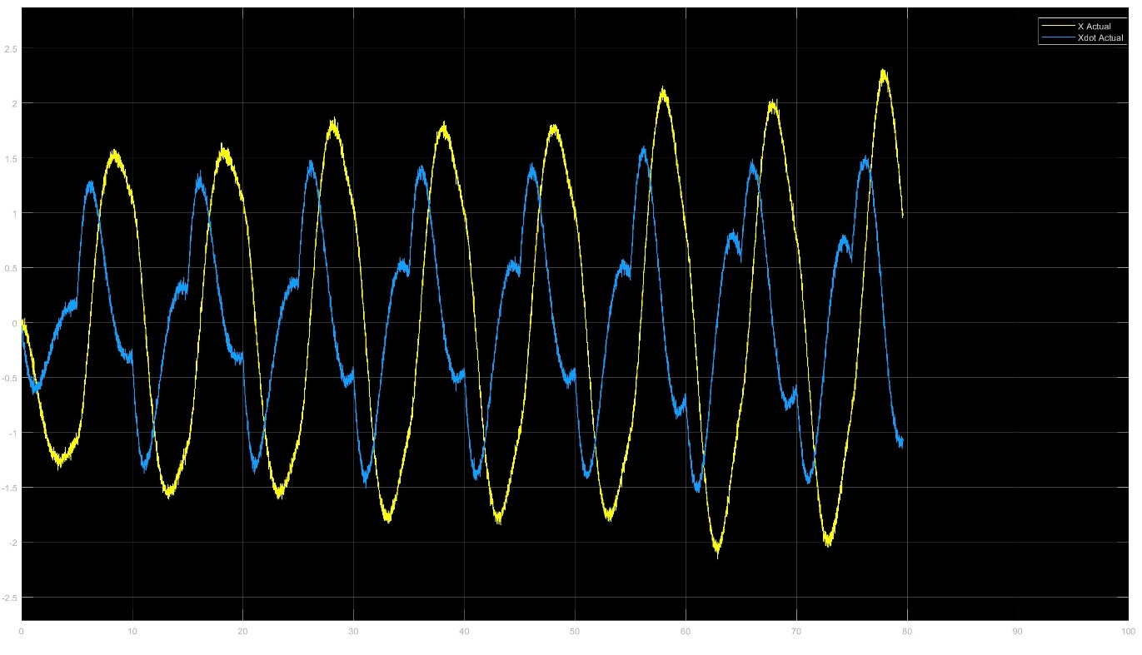

*The use of limited counter lets the Kalman filter run at 1Hz.*

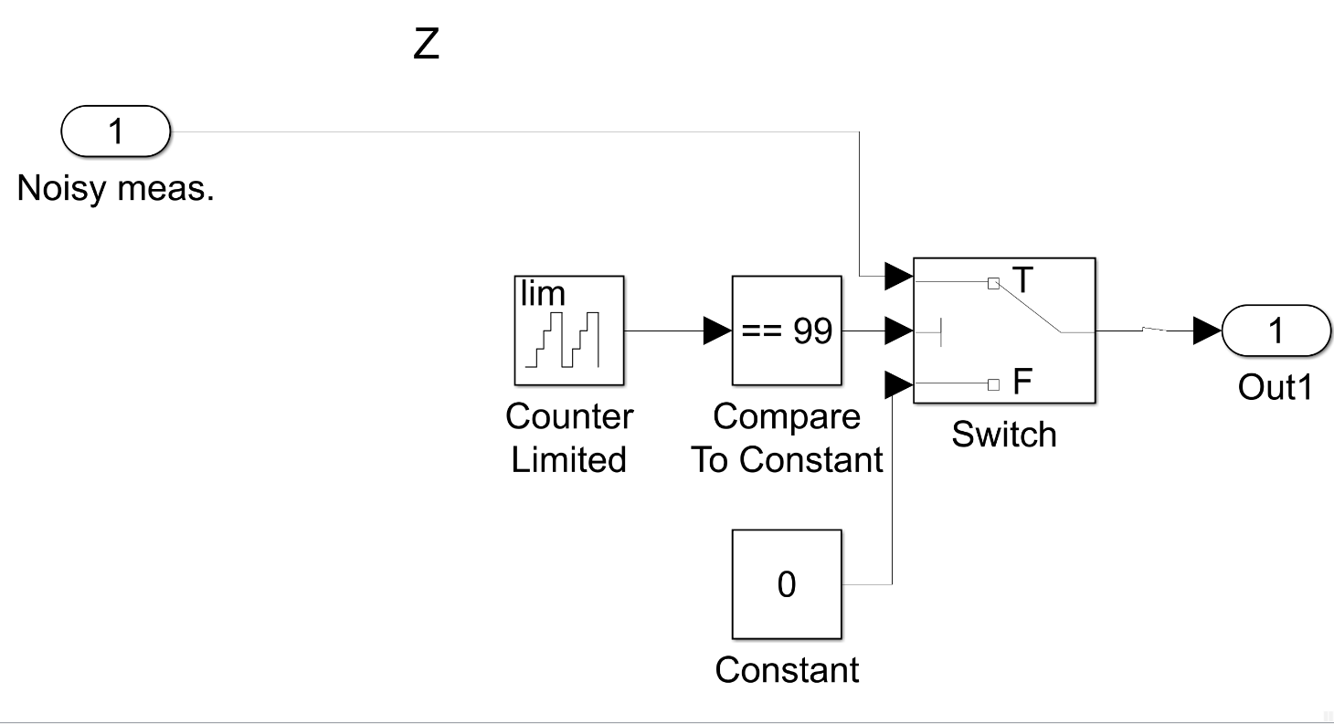

1. The following shows figure shows a single Kalman filter bank.

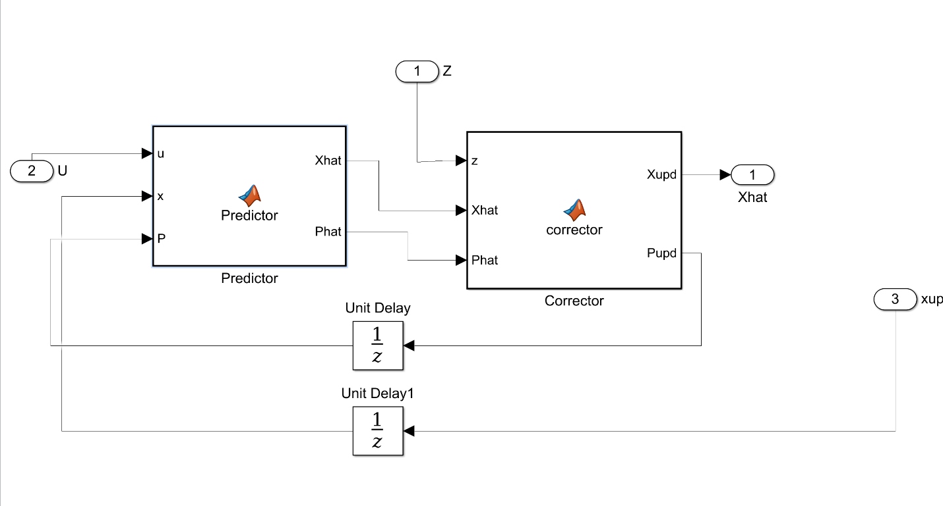

MATLAB Code for the Kalman filter (where b=0.8) :-

*Predictor block*

function [Xhat,Phat] = Predictor(u,x,P)

Q=10*eye(2);b =[0; 1];

a=[0 1;-1 -.8]; %[0 1;-k -b]

ad=expm(a*0.01);

bd=inv(a)*(ad-eye(2))*b;

f=[-a Q;

zeros(2,2) a'];

g=expm(f*0.01);

Qd=g(3:4,3:4)'*g(1:2,3:4);

Xhat=ad*x+bd*u; %State prediction

Phat=ad*P+ad'*Qd; %Covariance prediction

End

*Corrector block*

function [Xupd,Pupd] = corrector(z,Xhat,Phat)

h=eye(2);

r=eye(2);

if z(1) == 0 && z(2) == 0

Xupd = Xhat;

Pupd = Phat;

else

rd= 1 /0.01 * r;

K=Phat*h'*inv(h*Phat*h'+rd);

Pupd=(eye(2)-K*h)*Phat*(eye(2)-K*h)'+K*rd*K';

Xupd=Xhat+K*(z-h*Xhat);

end

end

*Block diagram of the entire plant*

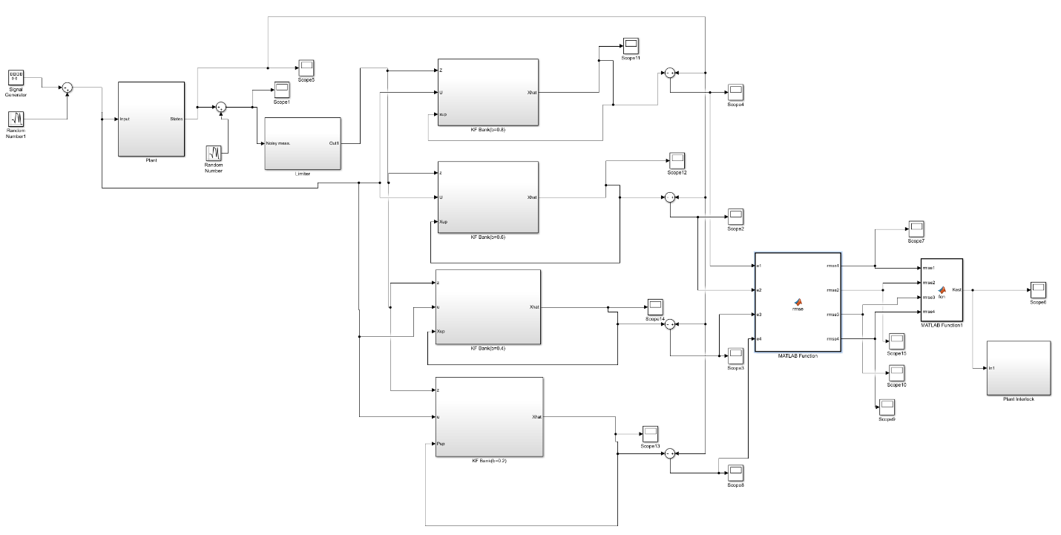

The values of Q and R selected are: Q=10*eye(2), R= eye(2).

b=0.8

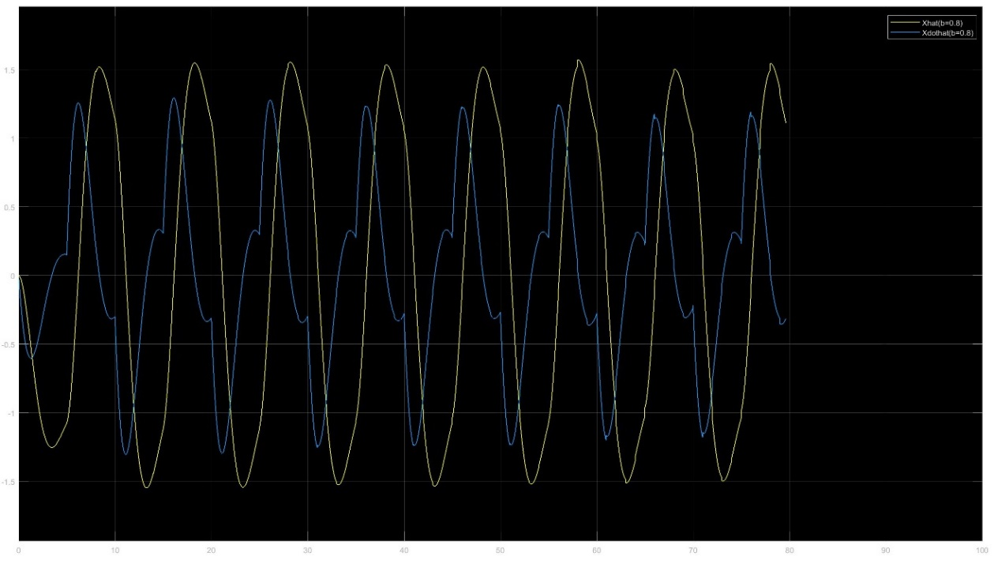

Error (b=0.8)

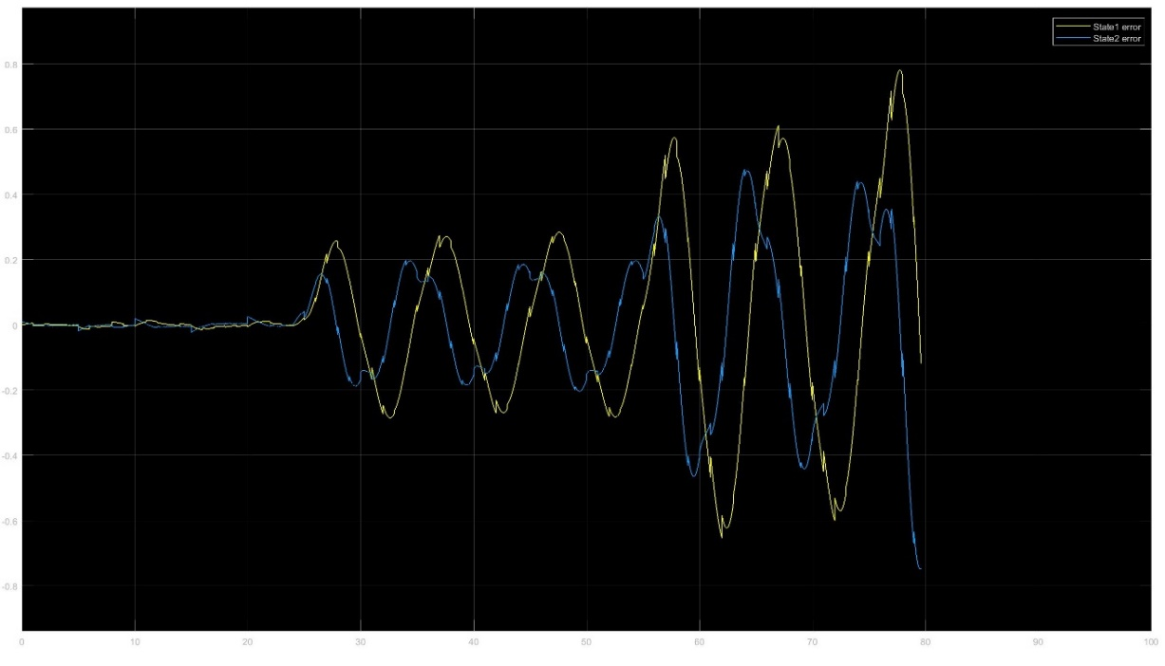

b=0.6

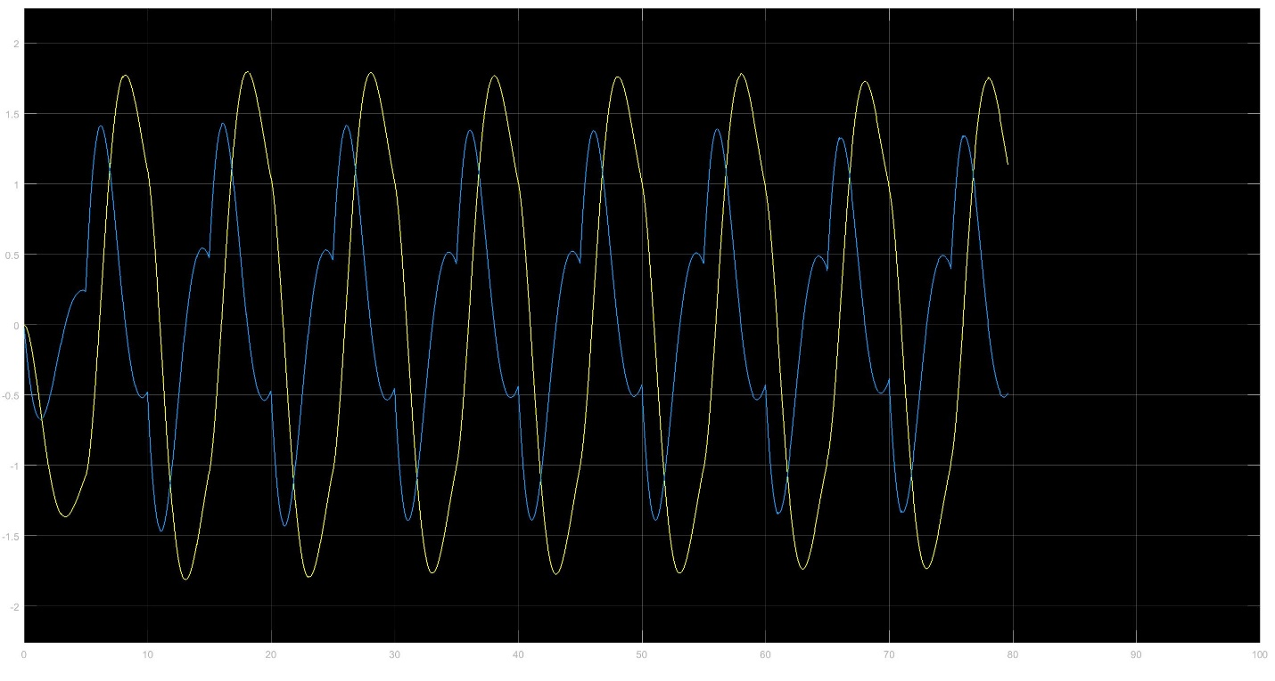

Error (b=0.6)

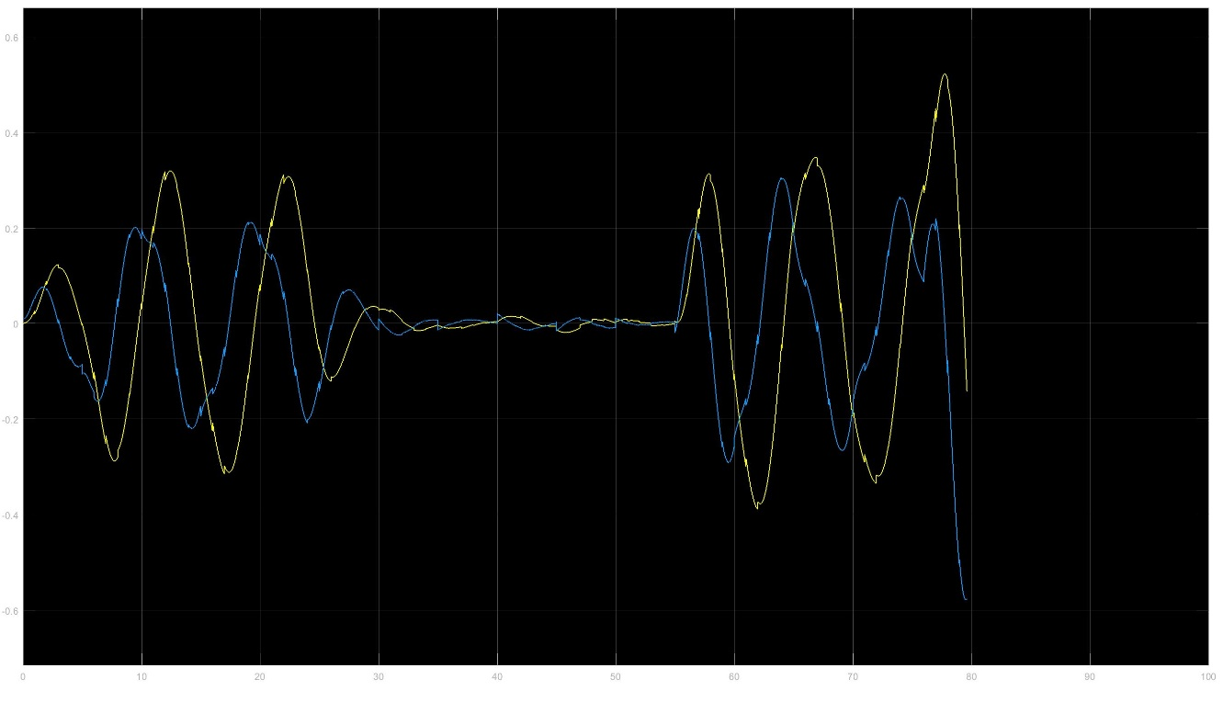

b = 0.4

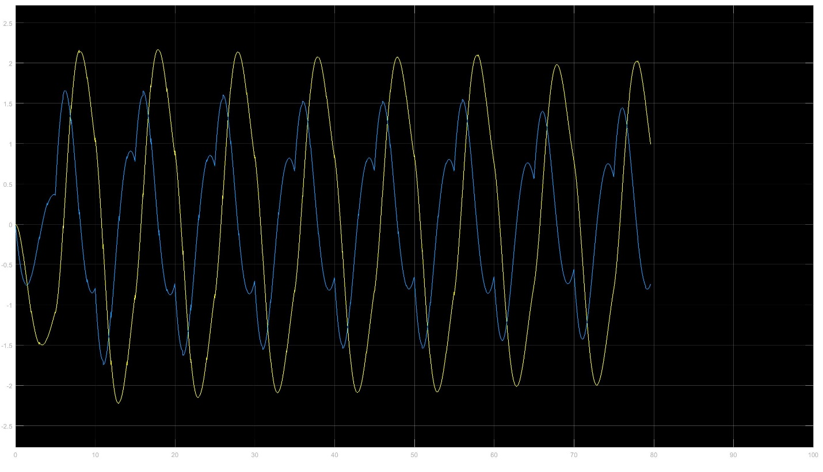

Error (b=0.4)

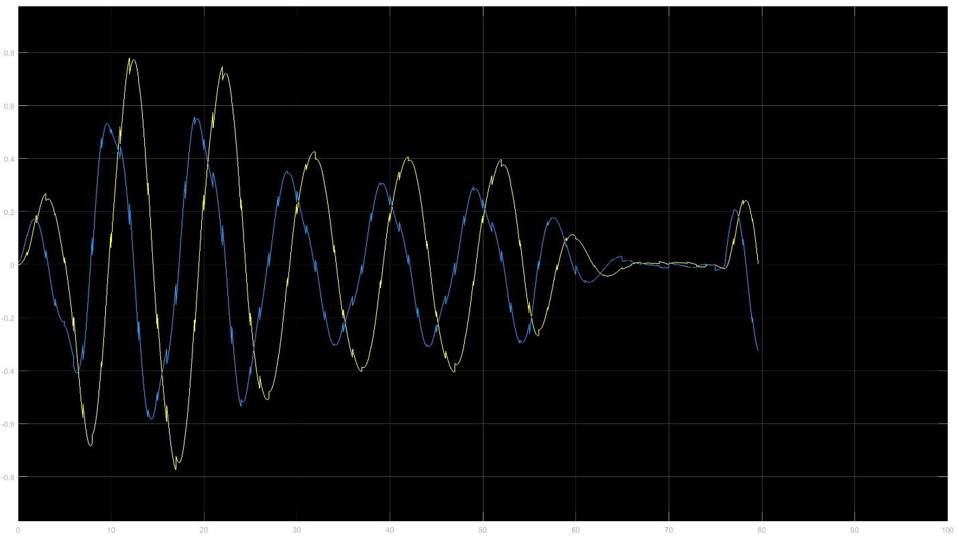

b = 0.2

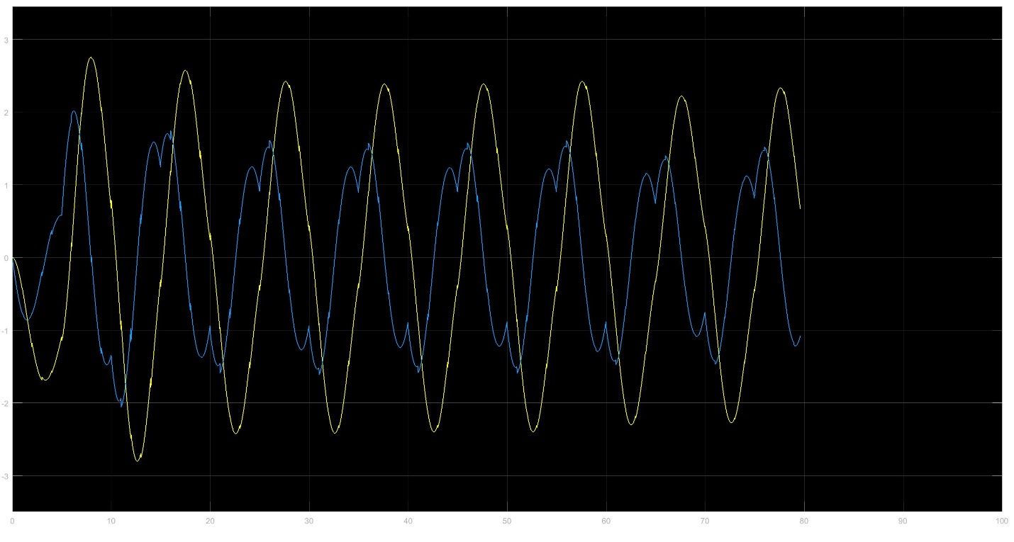

Error (b=0.2)

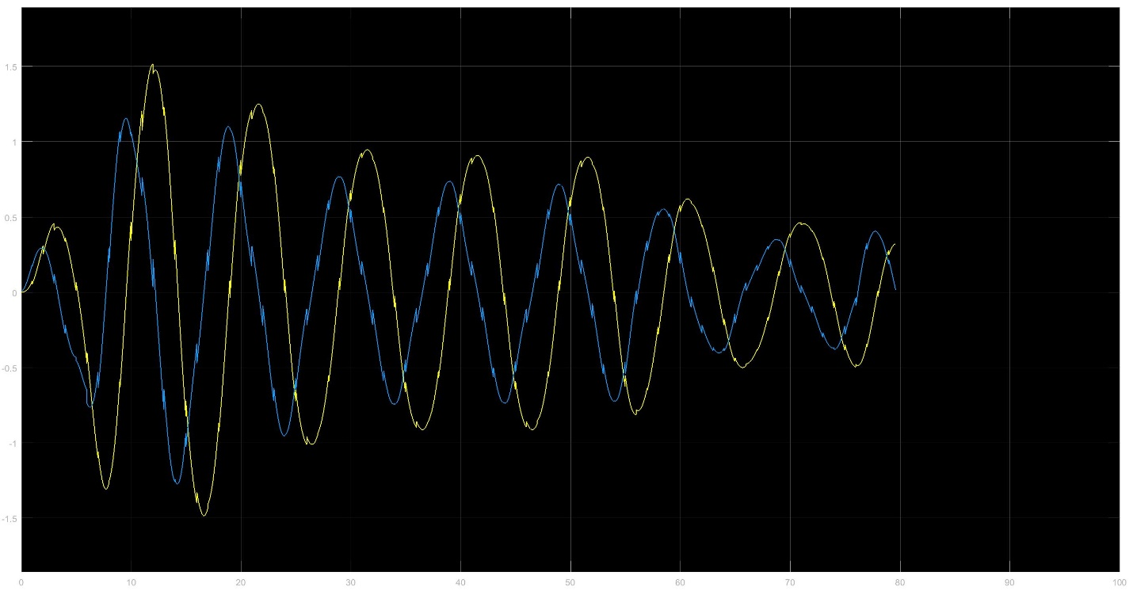

1. To normalize the error, we take the RMSE of the errors and observe the different plots for different values of b.

The MATLAB code for RMSE calculation is as follows :

function [rmse1,rmse2,rmse3,rmse4] = rmse(e1,e2,e3,e4)

rmse1=sqrt(e1(1)^2+e1(2)^2);

rmse2=sqrt(e2(1)^2+e2(2)^2);

rmse3=sqrt(e3(1)^2+e3(2)^2);

rmse4=sqrt(e4(1)^2+e4(2)^2);

end

The MATLAB code for K estimates is as follows :

function Kest = fcn(rmse1,rmse2,rmse3,rmse4)

[j,k]=min([rmse1,rmse2,rmse3,rmse4]);

Kest=.8;

switch k

case 1

Kest=.8;

case 2

Kest=0.6;

case 3

Kest=0.4;

case 4

Kest=0.2;

end

end

For b = 0.8

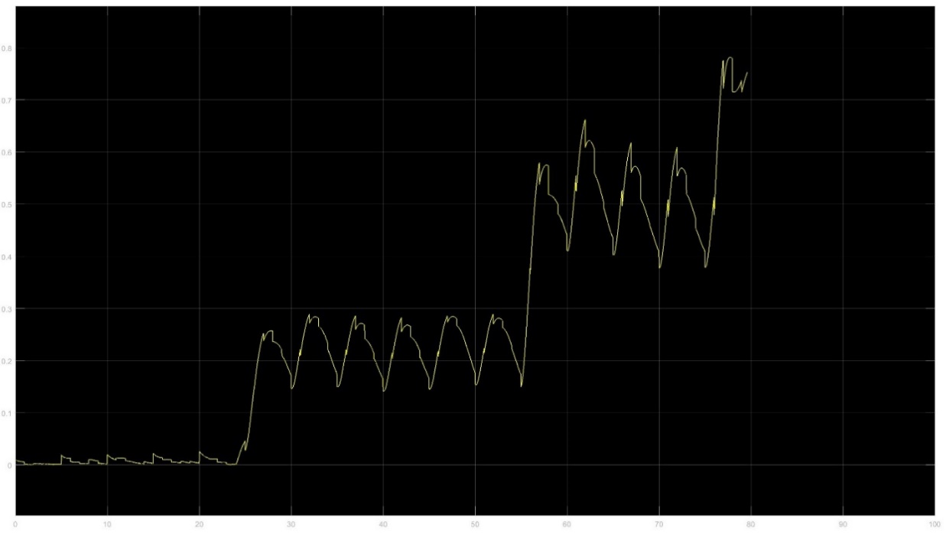

b = 0.6

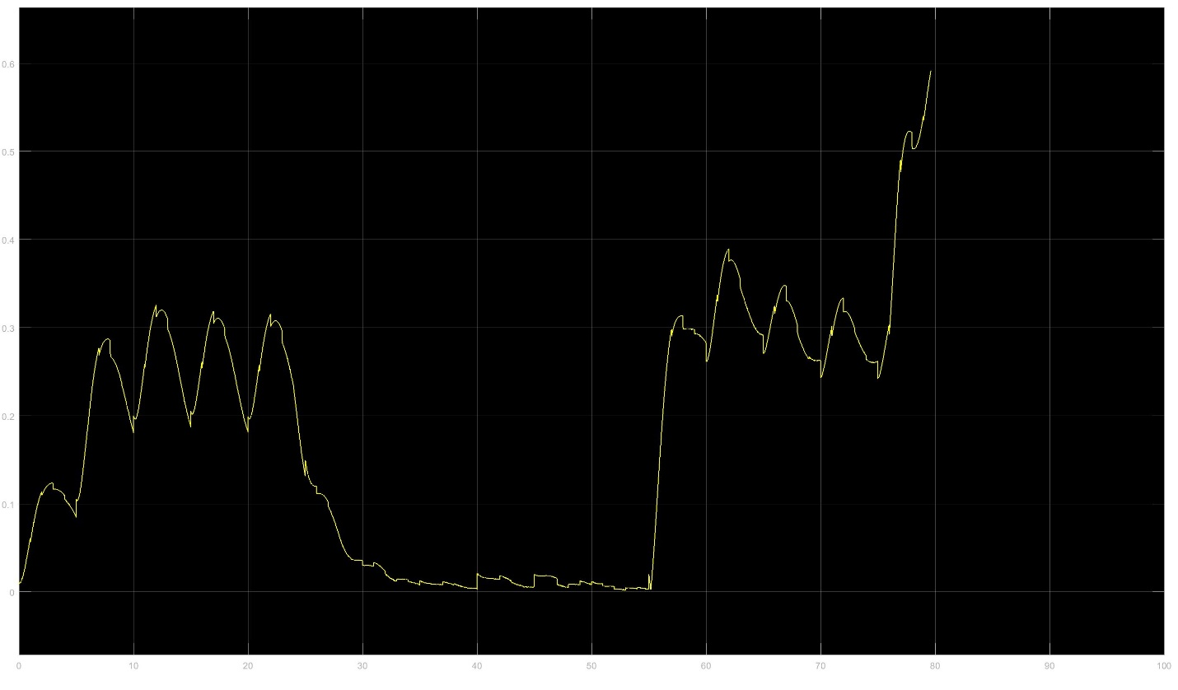

b = 0.4

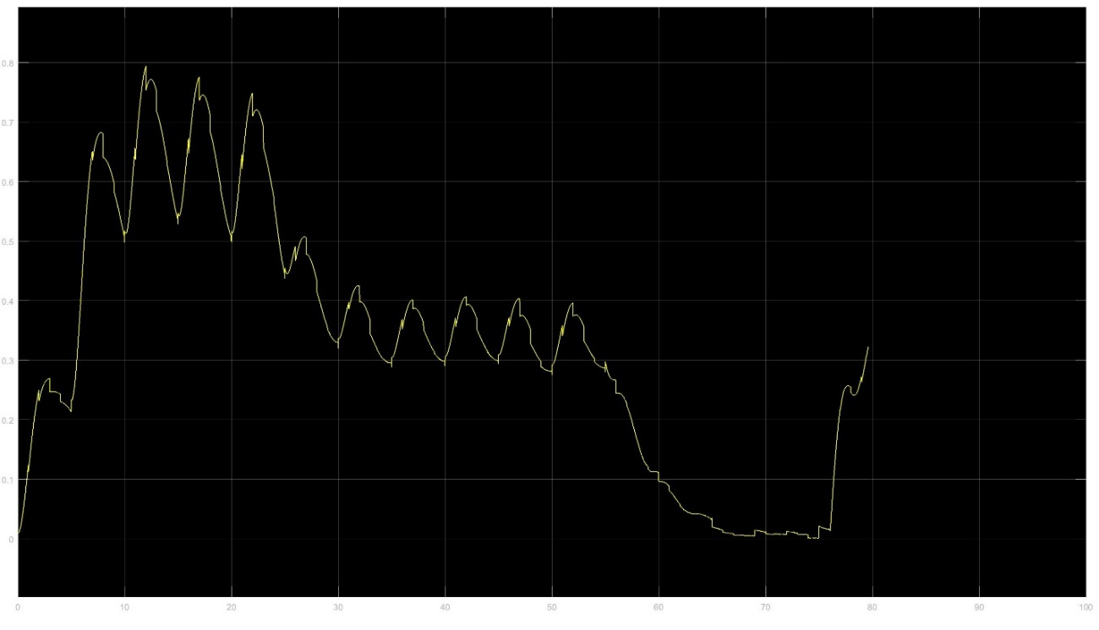

b = 0.2

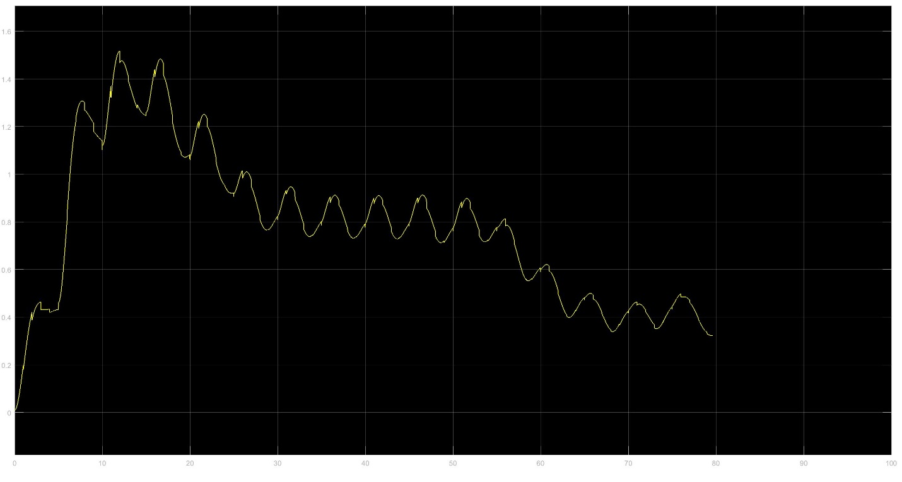

From the above plots, at b = 0.6, the error is minimum for a longer time. This means that the filter performs optimally when b=0.6. Therefore select the Kalman filter with b=0.6.

The following figure shows that the system continues to work till 79s although the third failure occurred at around 76s. It took 3s for the system to stop.

